Problem Statement: | ASSIGNMENT 2 | Name: Sankarshan  Roll No: 2301410027  Course: BTech CSE  (Cyber Security)
Modern operating systems are responsible for initializing system components, creating processes, managing execution, and gracefully shutting down. This lab aims to simulate these core concepts using Python, helping students visualize how processes are handled at the OS level. The focus is on creating a simplified startup mechanism that spawns multiple processes and logs their lifecycle using the multiprocessing and logging modules. This hands-on simulation enhances conceptual clarity and promotes coding proficiency in scripting real-world OS behavior.
Sub-Task 1: Initialize the logging configuration

CODE

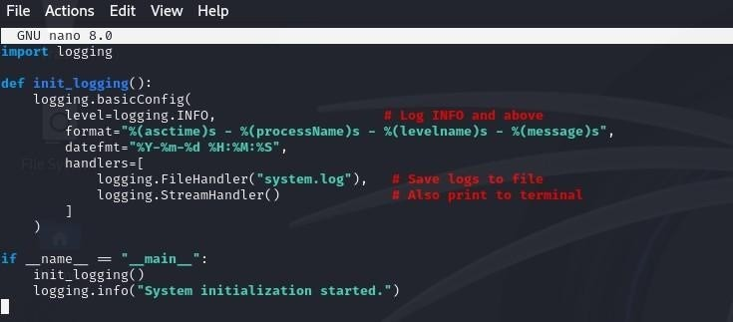
OUTPUT

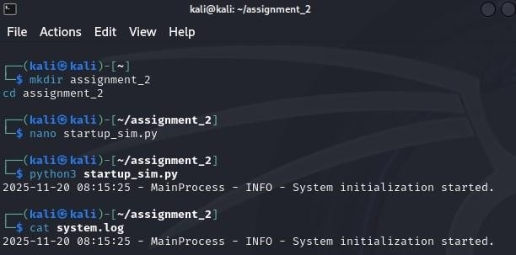
Define a function that simulates a process task (e.g., sleep for 2
seconds).

CODE
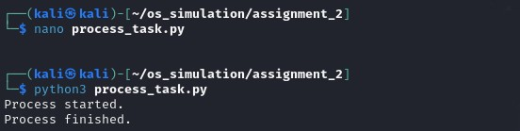
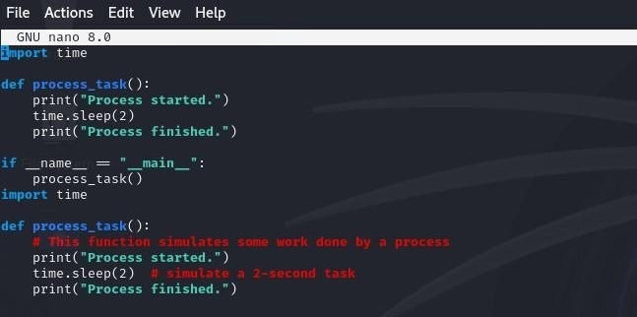
OUTPUT

Create at least two processes and start them concurrently.

CODE

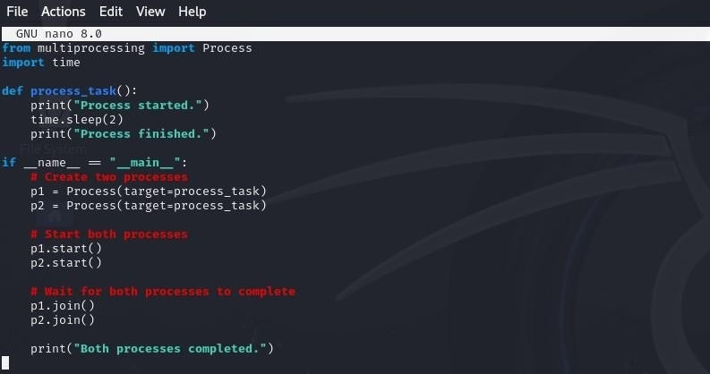

OUTPUT

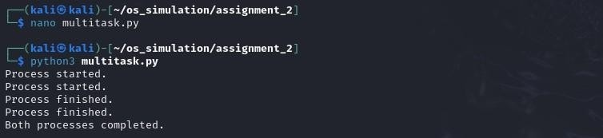
Ensure proper termination and joining of processes, and verify the
output in the log file.

CODE
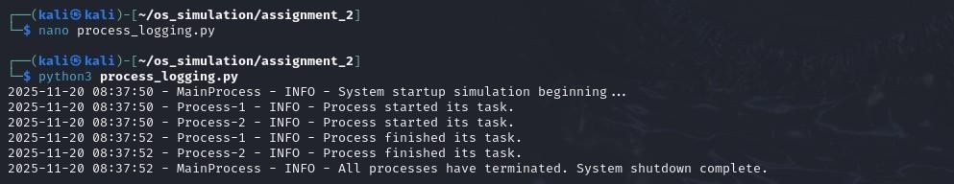
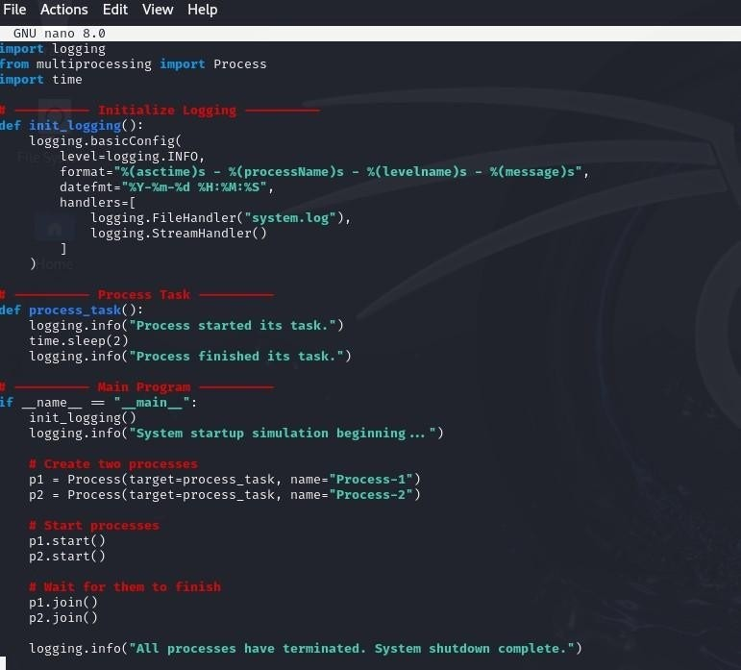

OUTPUT

